
Ocean robotics project leader Cesar Harada is looking for a personal assistant in London to develop Protei, a revolutionary sailing technology for ocean cleaning and open source sailing science. You would assist Harada manage an international team of about 30 scientists, engineers and designers in the early stage of an ocean technology start up and Non-profit organisation. The work would range from business development to team management and from grant writing to assisting in the production of prototypes. You may have the opportunity to travel and install exhibitions, to test prototypes in the water and do PR work.

Are you the person we are looking for? Please contact Cesar Harada for more information: contact@protei.org. For more information about Protei, protei.org

Your profile
You are enthusiastic and open minded and have a strong ability to keep overview in complex situations. You are pro-active and motivated to take Protei to the next level.

Required Skills
Administration and business;
Team management;
Accounting;
Non-profit development;
Business development;
Community moderation, web content management.
Excellent written and spoken English;
HTML is required. CSS, PHP, MySQL, processing, C are a plus;
Familiarity with CMSs (google sites, Wordpress);
Basics in sailing and physics required.
English + 1 other language minimum

Required Interests
Ocean science, navigation;
Innovation, technology;
Environmental activism;
Open Hardware and Hackers Culture;
Hands on work in the workshop or in the field;

Practical Details
Hours: part-time or full-time
Work start: as soon as possible
Location: London, Shoreditch, UK
Fee: for the first 3 months you may not receive a fee but would be commissioned per task. In a few months time, the general administrative position should be funded. This position would be first in line for an approximate fee of €3000 p/month.

Interested?
Send your resume and motivation to Cesar Harada: contact@protei.org. Suitable candidates will be invited for a (Skype) interview.
Deadline for application: December 16th, 2011

Protei
Looking for Personal Assistant for Cesar Harada, to develop an international ocean robotics project

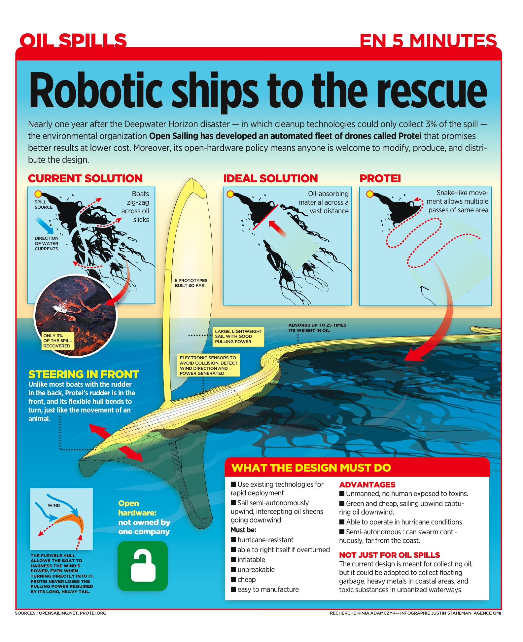
Protei
About Protei

During summer 2011, V2_ Institute for the Unstable Media and the Protei team developed the first full scale model of Protei, an oil spill cleaning sailing drone. Protei is a unique project, which aims to sustain our precious environment with the Open Hardware philosophy.

We are now ready for the next steps. In 2012, we plan to create multiple 1m RC controlled vessels, eventually resulting into a 6m long manned, shape-shifting version of Protei. The goal is to present the 6m version during the BLUE festival in San Francisco, september 2012 and many other major events. To establish this work, a worldwide team of collaborators will work on various aspects of Protei, such as AI, swarm behavior, the physics and mechanics of the sail and hull, the electronics on board etc. The collaborators weekly meet on Skype and have formed sub-groups around the aforementioned topics. It is a challenge to guide and direct such a diverse and globally wide-spread group. That's why we need your assistance.

